Functional Requirement

Feature | Use Case
Translation system | UC-01: Scan Chinese words and Location names  UC-02: View the explanation of scanned word  UC-03: Get Chinese pronunciation of scanned word  UC-04: Lock/Unlock the screen displaying the text of scanned word
Map system | UC-05: View the Location on map  UC-06: View all Location from their own Favorites on the map  UC-07: Get route of a Location stored in Favorites  UC-08: Get route of the scanned Location
Favorites system | UC-09: Add the scanned Location into Favorites  UC-10: Delete a Location from Favorites  UC-11: View the Location information in Favorites  UC-12: Sort Locations in Favorites by district name  UC-13: Sort Locations in Favorites by date  UC-14: Search Locations by key word in Favorites  UC-15: Get the pronunciation of Location name in Favorites  UC-16: Add scanned words into Word book  UC-17: Delete a word from Word book  UC-18: View Chinese words and related information in Word book  UC-19: Sort words in Word book by date  UC-20: Sort words in Word book alphabetically  UC-21: Search Chinese words in Word book  UC-22: Get the pronunciation of a Chinese word in Word book

1 Feature Name
Translation system

1.1 Feature Process Flow
Users can translate Chinese words and Location names into English by scanning them with the built-in camera of their mobile phone. After viewing the English translation of a word, users can also select the text-to-speech function to listen to the pronunciation of the Chinese word.

1.2 Use Case(s)

Use Case ID: | UC-01
Use Case Name: | Scan Chinese words and Location names
Created By: | Ruijuan Liu  Yirui Wang | Last Updated By: | Ruijuan Liu  Yirui Wang
Date Created: |  | Last Revision Date:
Actors: | Users
Description: | Users can scan Chinese words and Location names by using built-in camera.
Trigger: | Users choose to scan Chinese words or Location names in China.
Preconditions: | 1. Users have downloaded ‘Scan in Travel’ application on mobile phone.  2. Users unfold the ‘Scan in Travel’ application.
Post-conditions: | System shall get the searchable text of the scanned Chinese word (or Location name).
Normal Flow: | 1. Users choose to scan Chinese words or Location names in China.  2. System shall invoke the built-in camera of users’ mobile phones.  3. System shall provide user interface for users to scan Chinese words (or Location names) by using built-in camera.  4. Users use the built-in camera of their mobile phone to scan the image of a Chinese word (or Location name).  5. System shall capture the image of the scanned Chinese word (or Location name).  6. System shall recognize the Chinese word（or Location name) and convert the image into searchable text of the scanned Chinese word (or Location name).
Alternative Flows: | N/A
Exceptions: | In the step 3 of the Normal Flow, if the system cannot recognize the built-in camera of users’ mobile phone.  1. System shall provide the user interface to display the error message. “Cannot recognize your camera.”  2. Use case resumes on step 2 of the Normal Flow.  In step 5 of Normal Flow, if users do not let the built-in camera aim at the Chinese word (or Location name).  1. System will not get anything about the searchable text of the scanned image.  2. Use case resumes on step 5 of Normal Flow.
Includes:
Frequency of Use: | Ten times per day.
Special Requirements: | 1. Correctness of the recognition.  2. Speed of the recognition.
Assumptions: | 1. Users understand English.  2. Users know how to scan the words.
Notes and Issues: | 1. What is the maximum length of the scanned words?  2. What is the language that the system can recognize?

Activity Diagram:

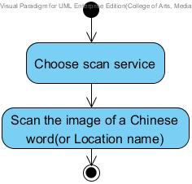

Use Case ID: | UC-02
Use Case Name: | View the explanation of scanned word
Created By: | Ruijuan Liu  Yirui Wang | Last Updated By: | Ruijuan Liu  Yirui Wang
Date Created: |  | Last Revision Date:
Actors: | Users  Microsoft Translator API
Description: | Users can view the explanation (i.e. meaning, pronunciation) of the scanned word in English.
Trigger: | 1. Users want to know the explanation of the scanned word.  2. Users have scanned Chinese word or Location names successfully.
Preconditions: | 1. Users have scanned Chinese word or Location name successfully.  2. System has got the searchable text of scanned Chinese word (or Location name).
Post-conditions: | Users can view the explanation (i.e. meaning, pronunciation) of the scanned word in English.
Normal Flow: | 1. Users choose to view the explanation of the scanned word.  2. System shall send the text of the scanned Chinese word (or Location name) to Microsoft Translator API.  3. Microsoft Translator API shall translate the text into English.  4. System shall receive the explanation (i.e. meaning, pronunciation) of the scanned word in English.  5. System shall provide the user interface to display the text of the  Chinese word and the meaning of the scanned word in English.  6. Users can view the meaning of the scanned word in English.
Alternative Flows: | N/A
Exceptions: | In step 1 of Normal Flow, if no internet access.  - System shall provide the user interface to display the error message. “No internet access.”  - Use case ends.  In the step 3 of the Normal Flow, if the system cannot find the explanation of the scanned word.  1. System shall provide the user interface to display the error message. “Cannot find the explanation of this word.”  2. Use case ends.
Includes:
Frequency of Use: | Ten times per day.
Special Requirements: | Correctness of the translation.
Assumptions: | 1. Users understand English.  2. Users knows how to operate smart phones.
Notes and Issues: | 1. What is the language that the system can translate?  2. How much translation of the scanned word should be?

Activity Diagram:

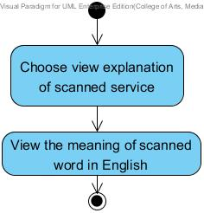

Use Case ID: | UC-03
Use Case Name: | Get Chinese pronunciation of scanned word
Created By: | Ruijuan Liu  Yirui Wang | Last Updated By: | Ruijuan Liu  Yirui Wang
Date Created: |  | Last Revision Date:
Actors: | Users  Microsoft Translator API
Description: | Users can select Text-to-Speech to get the Chinese pronunciation of the word.
Trigger: | Users want to get the Chinese pronunciation of scanned word.
Preconditions: | 1. Users have scanned the Chinese word (or Location name) and viewed the explanation of the scanned word successfully.
Post-conditions: | Users can get the Chinese pronunciation of the scanned word.
Normal Flow: | 1. System shall send the text of the scanned Chinese word (or Location name) to Microsoft Translator API.  2. Microsoft Translator API shall send the Chinese pronunciation of the Chinese word to system.  3. System shall receive the pronunciation of the scanned word in Chinese.  4. System shall provide the service for users to get the proper Chinese pronunciation of the word.  5. Users choose to get the pronunciation of the scanned word in Chinese.  6. System shall pronounce the word to users in Chinese.  7. Users get the Chinese pronunciation of scanned word.
Alternative Flows: | N/A
Exceptions: | In step 1 of Normal Flow, if no internet access.  1. System shall provide the user interface to display the error message. “No internet access.”  2. Use case ends.  In the step 3 of the Normal Flow, if the system cannot find the pronunciation of the scanned word.  1. System shall provide the user interface to display the error message. “Cannot find the pronunciation of this word.”  2. Use case ends.
Includes:
Frequency of Use: | Ten times per day.
Special Requirements: | Correctness of the pronunciation.
Assumptions: | 1. Users understand English.  2. Users knows how to operate smart phones.
Notes and Issues: | 1. What language the system can provide the pronunciation?  2. How is the pronunciation of the scanned word?

Activity Diagram:

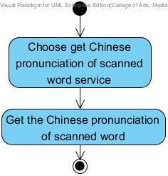

Use Case ID: | UC-04
Use Case Name: | Lock/Unlock the screen displaying the text of scanned word
Created By: | Ruijuan Liu  Yirui Wang | Last Updated By: | Ruijuan Liu  Yirui Wang
Date Created: |  | Last Revision Date:
Actors: | Users
Description: | Users can lock/unlock the screen which displays the text of the scanned word. (When locked, the scanning function will be disabled temporarily and the screen will keep the scanned image on display.)
Trigger: | Users want to keep the explanation of scanned word on display.
Preconditions: | 1. Users have scanned the Chinese word (or Location name) and viewed the explanation of the scanned word successfully.
Post-conditions: | Users can lock/unlock the screen.
Normal Flow: | 1. Users choose to keep the explanation of scanned word on display.  2. System shall provide the service for users to select to lock/unlock the screen which displays the text of the scanned word.  3. Users choose the ‘Lock’ service to lock the screen.  4. System shall receive the request from users to lock the screen which displays the text of the scanned word.  5. System shall lock the screen which displays the text of the scanned word. When locked, the scanning function will be disabled temporarily and the screen will keep the scanned word image on display.  6. Users choose the ‘Unlock’ service to unlock the screen.  7. System shall receive the request from users to unlock the screen which displays the text of the scanned word.  8. System shall unlock the screen which display the text of the previous scanned word. When unlocked, the scanning function will be available.  9. Users can scan other Chinese words and get their explanations.
Alternative Flows: | N/A
Exceptions: | N/A
Includes:
Frequency of Use: | Ten times per day.
Special Requirements: | N/A
Assumptions: | 1. Users understand English.  2. Users knows how to operate smart phones.  3. Users know how to lock/unlock the screen.
Notes and Issues: | N/A

2 Feature Name
Map system

2.1 Feature Process Flow
Users can keep their own map of every Location that they saved. The system lets users see every saved Location on a map, and check the details of each Location. Besides, users can scan a Location name and find where it is located on a map. The system will guide users to get to the Location by providing a route on a map.

2.2 Use Case(s)

Use Case ID: | UC-05
Use Case Name: | View the Location on map
Created By: | Ruijuan Liu  Yirui Wang | Last Updated By: | Ruijuan Liu  Yirui Wang
Date Created: |  | Last Revision Date:
Actors: | Users  Google Maps API
Description: | Users can view the Location on the map if the scanned word is the name of a Location.
Trigger: | Users select the service to view the Location on the map.
Preconditions: | 1. Users have scanned the Location name successfully.  2. System shall get the searchable text of the scanned Location name.
Post-conditions: | Users can view the Location on the map.
Normal Flow: | 1. Users select the service to view the Location on the map.  2. System shall send the text of Location name to the Google Maps API.  3. Google Maps API shall send the information of this Location name to system.  4. System shall receive the related geometry information of the Location from Google Maps API.  5. System shall provide the user interface to display a list of Locations related to the text of the Location name.  6. Users can select one Location name he or she wants to know more information.  7. System shall provide the user interface to display the Location selected by users on the map.  8. Users can view the Location on the map.
Alternative Flows: | In the step 6 of the Normal Flow, if users want to get more detailed map about this Location.  1. System shall provide the service to zoom in the map.  2. Users select to zoom in the map.  3. System shall change the location size of the map.  4. System shall show a more detailed map to users.  5. Use case ends.  In the step 6 of the Normal Flow, if users want to get a more general map about this Location.  1. System shall provide the service to zoom out the map.  2. Users select to zoom out the map.  3. System shall change the location size of the map.  4. System shall show a more general map to users.  5. Use case ends.  In the step 3 of the Normal Flow, if system cannot find any location related to the scanned word.  1. System shall provide the user interface to display the error message. “Cannot find any location related to this word.”  2. Use case ends.  In the step 1 of the Normal Flow, if users decide to not get map of this Location.  1. System shall provide the service for users to cancel the service of searching the Location from Google Maps API.  2. Users choose to cancel the service.  3. System shall cancel the service of searching the Location from Google Maps API.  4. Use case ends.
Exceptions: | In step 2 of Normal Flow, if no internet access.  1. System shall provide the user interface to display the error message. “No internet access.”  2. Use case ends.
Includes:
Frequency of Use: | Ten times per day.
Special Requirements: | 1. Correctness and expatiation of the map.  2. Correctness and comprehensiveness of the Location catalogue.
Assumptions: | 1. Users understand English.  2. Users knows how to operate smart phones.  3. Users know the basic information about the Location.  4. Users know how to use the electronic map.
Notes and Issues: | 1. What is the proportion of the map?  2. How could the system figure out where users want to look in detail?  3. How could the system figure out how much general users want?

Use Case ID: | UC-06
Use Case Name: | View all Location from their own Favorites on the map
Created By: | Ruijuan Liu  Yirui Wang | Last Updated By: | Ruijuan Liu  Yirui Wang
Date Created: |  | Last Revision Date:
Actors: | Users  Google Maps API
Description: | Users can view all Locations from their own Favorites on the map.
Trigger: | Users choose to view all Locations in their own Favorites.
Preconditions: | 1. Users have saved Location information into their Favorites before.
Post-conditions: | Users can view all Locations from their Favorites on the map.
Normal Flow: | - Users choose to view all Locations from their Favorites on the map.  - System shall retrieve all the Location data in their own Favorites from database.  - System shall send all the Locations geometry information to the Google Maps API.  - System shall provide the user interface to display all the Locations on the map.  - Users can view all Locations on the map.
Alternative Flows: | In the step 5 of the Normal Flow, if users want to get more detailed map about these Locations.  1. System shall provide the service to zoom in the map.  2. Users select to zoom in the map.  3. System shall change the location size of the map.  4. System shall show a more detailed map to users.  In the step 6 of the Normal Flow, if users want to get a more general map about these Locations.  1. System shall provide the service to zoom out the map.  2. Users select to zoom out the map.  3. System shall change the location size of the map.  4. System shall show a more general map to users.  In the step 1 of the Normal Flow, if users decide not to get map of this Location.  1. System shall provide the service for users to cancel the service of searching the Location from Google Maps API.  2. Users choose to cancel the service.  3. System shall cancel the service of searching the Location from Google Maps API.  4. Use case ends.
Exceptions: | In step 1 of Normal Flow, if no internet access.  1. System shall provide the user interface to display the error message. “No internet access.”  2. Use case ends.
Includes:
Frequency of Use: | Ten times per day.
Special Requirements: | 1. Correctness and expatiation of the map.  2. Correctness and comprehensiveness of Locations.
Assumptions: | 1. Users know how to use the electronic map.  2. Users have saved Location(s) into their own Favorites before.
Notes and Issues: | 1. What is the proportion of the map?  2. How could the system figures out where user wants to look in detail?  3. How could the system figures out how much general users want?

Use Case ID: | UC-07
Use Case Name: | Get route of a Location stored in Favorites
Created By: | Ruijuan Liu  Yirui Wang | Last Updated By: | Ruijuan Liu  Yirui Wang
Date Created: |  | Last Revision Date:
Actors: | Users  Google Maps API  Global Position System
Description: | Users can view the map that shows the route from the current position to a Location stored in Favorites.
Trigger: | Users choose to view get the route of a Location.
Preconditions: | 1. Users saved Location information into their Favorites before.
Post-conditions: | Users can get the map that shows the route from the current position to a Location stored in Favorites.
Normal Flow: | 1. Users select a Location from their own Favorites.  2. System shall provide the service for users to get the route of the Location.  3. Users shall choose the service to get route.  4. System shall send the Location geometry information selected by users to the Google Maps API.  5. System shall use Global Position System to get the current position of users.  6. System shall send the current position geometry information of users to the Google Maps API.  7. Google Maps API shall send the related information to the system.  8. System shall receive the route information from the current position to the Location selected by users in their own Favorites.  9. System shall provide the user interface to display the pin of the users’ current position and the Location selected by users.  10. System shall provide the user interface to display the route from the current position to the Location selected by users in their own Favorites.  11. Users can view the map that shows the route from the current position to the Location.
Alternative Flows: | In the step 11 of the Normal Flow, if users want to get more detailed map about these Locations.  1. System shall provide the service to zoom in the map.  2. Users select to zoom in the map.  3. System shall change the location size of the map.  4. System shall show a more detailed map to users.  In the step 11 of the Normal Flow, if users want to get a more general map about these Locations.  1. System shall provide the service to zoom out the map.  2. Users select to zoom out the map.  3. System shall change the location size of the map.  4. System shall show a more general map to users.  In the step 5 of the Normal Flow, if users did not open the GPS service on their mobile phone.  1. System shall provide the user interface to display the error message. “Please open your GPS service to allow Google Map to get your location.”  In the step 4 of the Normal Flow, if users decide to not get route from current position to the selected Location.  1. System shall provide the service for users to cancel the service of searching the route from the current position to the selected Location.  2. Users choose to cancel the service.  3. System shall cancel the service of searching the route from the current position to the selected Location.  4. Use case resumes on step 1 of Normal Flow.
Exceptions: | In step 4 of Normal Flow, if no internet access.  1. System shall provide the user interface to display the error message. “No internet access.”
Includes:
Frequency of Use: | Ten times per day.
Special Requirements: | 1. Correctness and expatiation of the map.  2. Correctness and comprehensiveness of the route.
Assumptions: | 1. Users understand English.  2. Uses know how to operate smart phones.  3. Users know how to use the electronic map.  4. Users saved Location(s) into their own Favorites before.
Notes and Issues: | 1. What is the proportion of the map?  2. How could the system figure out where user wants to look in detail?  3. How could the system figure out how much general users want?

Activity Diagram:

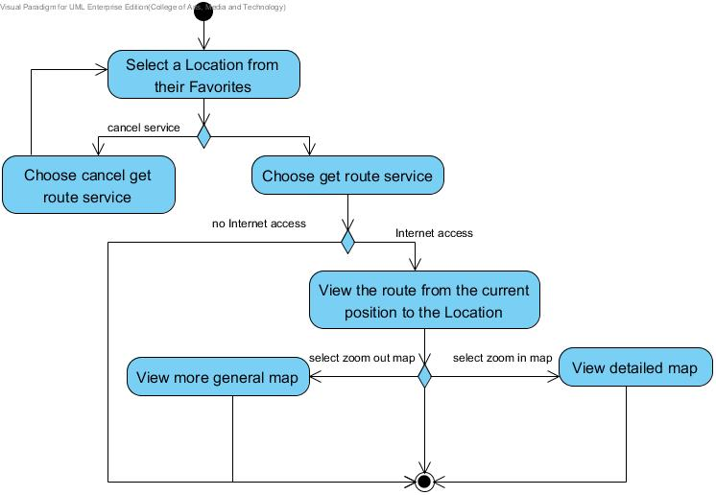

Use Case ID: | UC-08
Use Case Name: | Get route of the scanned Location
Created By: | Ruijuan Liu  Yirui Wang | Last Updated By: | Ruijuan Liu  Yirui Wang
Date Created: |  | Last Revision Date:
Actors: | Users  Google Maps API  Global Position System
Description: | Users can view the map that shows the route from the current position to the Location whose name is scanned.
Trigger: | Users choose to get the route of the scanned Location name.
Preconditions: | 1. Users scanned the Location name successfully.  2. System shall get the searchable text of the scanned Location name.
Post-conditions: | Users can get the map that shows the route from the current position to the Location whose name is scanned.
Normal Flow: | 1. Users choose to get the route of the scanned Location name.  2. System shall send the text of the scanned Location name to the Google Maps API.  3. System shall provide the service for users to get the route of the Location.  4. Users shall choose the service to get route.  5. System shall send the Location geometry information of scanned Location to the Google Maps API.  6. System shall use Global Position System to get the current position of users.  7. System shall send the current position geometry information of users to the Google Maps API.  8. Google Maps API shall send the related information to the system.  9. System shall receive the route information from the current position to the scanned Location from Google Maps API.  10. System shall provide the user interface to display the pin of the users’ current position and the scanned Location.  11. System shall provide the user interface to display the route from the current position to the scanned Location.  12. Users can view the map that shows the route from the current position to the Location whose name is scanned.
Alternative Flows: | In the step 11 of the Normal Flow, if users want to get more detailed map about these Locations.  1. System shall provide the service to zoom in the map.  2. Users select to zoom in the map.  3. System shall change the location size of the map.  4. System shall show a more detailed map to users.  In the step 11 of the Normal Flow, if users want to get a more general map about these Locations.  1. System shall provide the service to zoom out the map.  2. Users select to zoom out the map.  3. System shall change the location size of the map.  4. System shall show a more general map to users.  In the step 5 of the Normal Flow, if users did not open the GPS service on their mobile phone.  1. System shall provide the user interface to display the error message. “Please open your GPS service to allow Google Map to get your location.”  In the step 4 of the Normal Flow, if users decide not to get route from current position to the scanned Location.  1. System shall provide the service for users to cancel the service of searching the route from the current position to the scanned Location.  2. Users choose to cancel the service.  3. System shall cancel the service of searching the route from the current position to the scanned Location.  4. Use case resumes on step 2 of Normal Flow.
Exceptions: | In step 4 of Normal Flow, if no internet access.  1. System shall provide the user interface to display the error message. “No internet access.”
Includes:
Frequency of Use: | Ten times per day.
Special Requirements: | 1. Correctness and expatiation of the map.  2. Correctness and comprehensiveness of the route.
Assumptions: | 1. Users know how to use the electronic map.  2. Users scanned the Location name successfully.
Notes and Issues: | 1. What is the proportion of the map?  2. How could the system figure out where user wants to look in detail?  3. How could the system figure out how much general users want?

3 Feature Name
Favorites system

3.1 Feature Process Flow
Users can save Chinese words and their English translation to their own Word book. If users scan a Location name, they can also save the Location with its name, pictures, geometry information (i.e. latitude and longitude), and descriptions into their Favorites. Users can take the picture of the Location and write down their own description for it. Moreover, users can sort and search words in their own Word book and Locations in their Favorites.

3.2 Use Case(s)

Use Case ID: | UC-09
Use Case Name: | Add the scanned Location into Favorites
Created By: | Ruijuan Liu  Yirui Wang | Last Updated By: | Ruijuan Liu  Yirui Wang
Date Created: |  | Last Revision Date:
Actors: | Users
Description: | This use case shows how users add the scanned Location into their own Favorites.
Trigger: | Users select the service to add the scanned Location into their own Favorites.
Preconditions: | 1. The service to add the scanned Location into Favorites is available.  2. The system is on running status, and is on the interface which displays the scanned Location.
Post conditions: | System shall add the scanned Location with its name, pictures, geometry information, and description into database.
Normal Flow: | - Users select the service to add the scanned Location into their own Favourites.  - System shall provide the user interface to receive the data from users to add the scanned Location. The data include pictures and description information.  - System shall provide the name and geometry information of the scanned Location for users.  - Users add the pictures and description information about the scanned Location.  - Users select to add this Location.  - System shall add the scanned Location with its name, pictures, geometry information, and description into database.  7. System shall provide the user interface to display the successful message. “Location added successfully!”
Alternative Flows: | In the step 3 of Normal Flow, users can edit the name of the scanned Location which is provided by system.  1. System shall provide the service for users to edit the name of the Location.  2. Users edit the name of the scanned Location.  3. Use case resumes on step 3 of Normal Flow.  In the step 4 of Normal Flow, users can select to cancel the addition of the scanned Location into the Favorites.  - System shall provide the service for users to cancel the service of adding the scanned Location.  - Users select the service to cancel the addition of the scanned Location into the Favorites.  - System shall cancel the service of adding the scanned Location.  - Use case ends.
Exceptions: | In the step 6 of Normal Flow, the format of the scanned Location name that users provide is wrong.  - System shall provide the user interface to display the error message. “The length of the name should be shorter than 50.”  - Use case resumes on step 2 of Normal Flow.  In the step 6 of Normal Flow, the format of the description information that users provide is wrong.  1. System shall provide the user interface to display the error message. “The length of the description should be shorter than 500.”  2. Use case resumes on step 3 of Normal Flow.
Includes: | N/A
Frequency of Use: | About 30 times per day.
Special Requirements: | 1. The data of the scanned Location that are stored in database should be same as the data that users provide.  2. The data of the scanned Location that users provide must satisfy the proper formats.  3. The length of the name should be shorter than 50. The length of the description should be shorter than 500.
Assumptions: | 1. Users understand English language.  2. Users know how to operate smart phones.  3. Users know how to upload pictures.  4. Users know how to key the text on smart phones.
Notes and Issues: | - The speed of storing the added Location in the database.  - The completeness of data of the scanned Location which are added to database.

Activity Diagram:

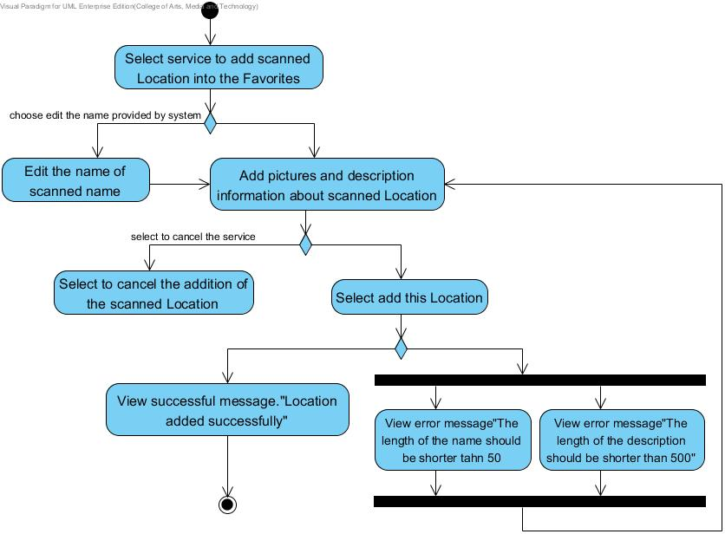

Use Case ID: | UC-10
Use Case Name: | Delete a Location from Favorites
Created By: | Ruijuan Liu  Yirui Wang |  | Last Updated By: | Ruijuan Liu  Yirui Wang
Date Created: |  |  | Last Revision Date:
Actors: |  | Users
Description: |  | This use case shows how users delete a Location from their own Favorites.
Trigger: |  | Users select the service to delete a Location from their own Favorites.
Preconditions: |  | 1. The service to delete a Location from Favorites is available.  2. The system is on running status, and is on the interface which displays the Locations from Favorites.
Post conditions: |  | System shall delete the data of the selected Location from database.
Normal Flow: |  | 1. Users select the service to delete a Location from their own Favorites.  2. System shall provide the service for users to delete a Location from their own Favorites.  3. System shall provide the user interface for users to select the Location that they want to delete.  4. Users select a Location to delete.  5. System shall prompt users to confirm the deletion of a selected Location in their own Favorites.  6. System shall provide the user interface to display the prompt message. “Are you sure to delete this Location?”  7. Users confirm the deletion of the selected Location.  8. System shall retrieve the data of the selected Location in the database.  9. System shall delete the data of the selected Location from database.  10. System shall provide the user interface to display the successful message. “Location deleted successfully!”
Alternative Flows: |  | In the step 4 of Normal Flow, users can select to cancel the deletion of the selected Location.  1. System shall provide the service for users to cancel the service of deleting the selected Location.  2. Users select to cancel the service of deleting the selected Location.  3. System shall cancel the service of deleting the selected Location.  4. Use case ends.
Exceptions: |  | In the step 8 of Normal Flow, the deletion of the selected Location fails.  1. System shall provide the user interface to display the error message. “Deletion failed.”  2. Use case resumes on step 2 of Normal Flow.
Includes: |  | N/A
Frequency of Use: |  | About 10 times per day
Special Requirements: |  | The Location whose data are deleted from database must be same as the Location that user select.
Assumptions: |  | 1. Users understand English language.  2. Users know how to operate smart phones.
Notes and Issues: |  | 1. The speed of deleting a selected Location from database.  2. The correctness and completeness of the deletion of the selected Location.

Activity Diagram:

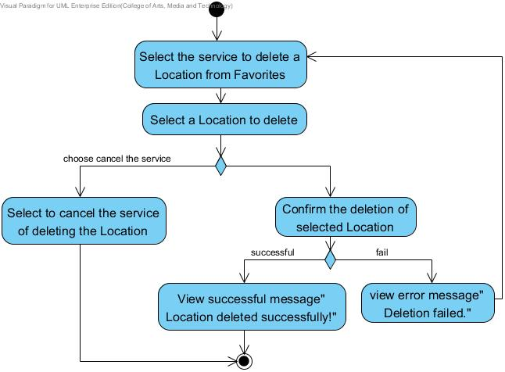

Use Case ID: | UC-11
Use Case Name: | View the Location information in Favorites
Created By: | Ruijuan Liu  Yirui Wang |  | Last Updated By: | Ruijuan Liu  Yirui Wang
Date Created: |  |  | Last Revision Date:
Actors: |  | User
Description: |  | This use case shows how users view the Location information in their Favorites, the information includes name, pictures, geometry location and descriptions.
Trigger: |  | Users select the service to view the Location information in their Favorites.
Preconditions: |  | 1. The service to view the information of a Location in Favorites is available.  2. The system is on running status, and is on the interface which displays the Locations from Favorites.
Post conditions: |  | System shall provide the user interface to display the selected Location information with name, pictures, geometry information and description in their favorites.
Normal Flow: |  | 1. Users select the service to view the Location information in their Favorites.  2. System shall provide the service for users to view the Location information with name, pictures, geometry information and descriptions in their Favorites.  3. System shall retrieve all the Location data in their own Favorites from database.  4. System shall provide a list of Locations from Favorites.  5. Users select a Location to view its information.  6. System shall retrieve the data of the selected Location in the database.  7. System shall provide the user interface to display the selected Location information with name, pictures, geometry information and description in their favorites.  8. Users can view the Location information with name, picture, geometry information and description in their favorites.
Alternative Flows: |  | N/A
Exceptions: |  | In the step 3 of Normal Flow, there is no Location found in database.  1. System shall provide the user interface to show prompt message. “No Location in your Favorites. You can add wherever you like.”  2. Use case ends.
Includes: |  | N/A
Frequency of Use: |  | About 20 times per day
Special Requirements: |  | The Location whose information are viewed from database must be same as the Location that user select.
Assumptions: |  | 1. Users understand English language.  2. Users know how to operate smart phones.
Notes and Issues: |  | 1. The speed of retrieving a selected Location from database.  2. The correctness and completeness of the data of the selected Location.

Use Case ID: | UC-12
Use Case Name: | Sort Locations in Favorites by district name
Created By: | Ruijuan Liu  Yirui Wang |  | Last Updated By: | Ruijuan Liu  Yirui Wang
Date Created: |  |  | Last Revision Date:
Actors: |  | Users
Description: |  | This use case shows how users sort Locations in their Favorites by district name.
Trigger: |  | Users select the service to sort Locations in their Favorites by district name.
Preconditions: |  | 1. The service to sort Locations in Favorites by district name is available.  2. The system is on running status, and is on the interface which displays the Locations from Favorites.
Post conditions: |  | System shall provide the user interface to display a list of names of sorted Locations by district. Districts’ names are sorted alphabetically. In each district, Location names are sorted alphabetically.
Normal Flow: |  | 1. Users select the service to sort Location in their Favorites by district name.  2. System shall provide the service for users to sort the Locations in Favorites by district name.  3. Users select to sort Locations in Favorites by district name.  4. System shall retrieve all the Location data in their own Favorites from database.  5. System shall sort all the Location data from database by district name.  6. System shall provide the user interface to display a list of names of sorted Locations by district. Districts’ names are sorted alphabetically. In each district, Location names are sorted alphabetically.  7. Users can view a list of names of sorted Locations by district.
Alternative Flows: |  | N/A
Exceptions: |  | In the step 4 of Normal Flow, there is no Location found in database.  1. System shall provide the user interface to show prompt message. “No Location in your Favorites. You can add wherever you like.”  2. Use case resumes on the Step 1 of Normal Flow.
Includes: |  | N/A
Frequency of Use: |  | About 20 times per day
Special Requirements: |  | N/A
Assumptions: |  | 1. Users understand English language.  2. Users know how to operate smart phones.
Notes and Issues: |  | 1. The speed of retrieving all Locations from database.  2. The speed of sorting all the Locations by district name.  3. The correctness of sorting all the Locations.

Activity Diagram:

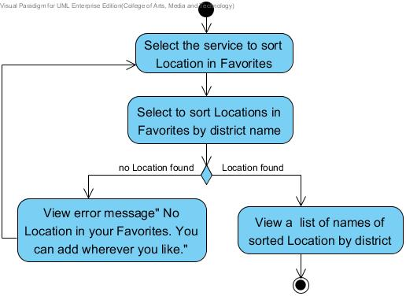
Use Case ID: | UC-13
Use Case Name: | Sort Locations in Favorites by date
Created By: | Ruijuan Liu  Yirui Wang |  | Last Updated By: | Ruijuan Liu  Yirui Wang
Date Created: |  |  | Last Revision Date:
Actors: |  | Users
Description: |  | This use case shows how users sort Locations in their Favorites by date they are added.
Trigger: |  | Users select the service to sort Locations in their Favorites by date they are added.
Preconditions: |  | 1. The service to sort Locations in Favorites by date they are added is available.  2. The system is on running status, and is on the interface which displays the Locations from Favorites.
Post conditions: |  | System shall provide the user interface to display a list of names of sorted Locations by date. Dates are sorted from the latest to the earliest.
Normal Flow: |  | 1. Users select the service to sort the Location in their Favorites by date they are added.  2. System shall provide the service for users to sort the Locations in Favorites by date they are added.  3. Users select to sort the Locations in Favorites by date they are added.  4. System shall retrieve all the Location data in their own Favorites from database.  5. System shall sort all the Location data from database by date they are added.  6. System shall provide the user interface to display a list of names of sorted Locations by date. Dates are sorted from the latest to the earliest.  7. Users can view a list of names of sorted Locations by date.
Alternative Flows: |  | N/A
Exceptions: |  | In the step 4 of Normal Flow, there is no Location found in database.  1. System shall provide the user interface to show prompt message. “No Location in your Favorites. You can add wherever you like.”  2. Use case ends.
Includes: |  | N/A
Frequency of Use: |  | About 20 times per day
Special Requirements: |  | N/A
Assumptions: |  | 1. Users understand English language.  2. Users know how to operate smart phones.
Notes and Issues: |  | 1. The speed of retrieving all Locations from database.  2. The speed of sorting all the Locations by district name.  3. The correctness of sorting all the Locations.

Use Case ID: | UC-14
Use Case Name: | Search Locations by key word in Favorites
Created By: | Ruijuan Liu  Yirui Wang |  | Last Updated By: | Ruijuan Liu  Yirui Wang
Date Created: |  |  | Last Revision Date:
Actors: |  | Users
Description: |  | This use case shows how users search Locations in their Favorites by key word.
Trigger: |  | Users select the service to search Locations in their Favorites by key word.
Preconditions: |  | 1. The service to search Locations in Favorites by key word is available.  2. The system is on running status, and is on the interface which receives the key word provided by users.
Post conditions: |  | System shall provide the user interface to display a (list of) name(s) of related Location(s).
Normal Flow: |  | 1. Users select the service to search Locations in their Favorites by key word.  2. System shall provide the service for users to search Locations by key word in their Favorites.  3. Users select the service to search Locations by key word in their Favorites.  4. System shall provide the user interface to receive the key word inputted by users.  5. Users provide the key word.  6. System retrieve the data of the Location(s) from database by key word.  7. System shall provide the user interface to display a (list of) name(s) of related Location(s).  8. Users can view a (list of) name(s) of Location(s) related to key word.
Alternative Flows: |  | N/A
Exceptions: |  | In the step 5 of Normal Flow, there is no Location found in database.  1. System shall provide the user interface to display the error message. “No Location found related to the key word.”  2. Use case resumes on the Step 3 of Normal Flow.
Includes: |  | N/A
Frequency of Use: |  | About 20 times per day
Special Requirements: |  | The correctness of the Locations displayed are related to the key word that users provides.
Assumptions: |  | 1. Users understand English language.  2. Users know how to operate smart phones.
Notes and Issues: |  | 1. The algorithm of retrieving all Locations from database by key word.  2. The correctness of searching the Locations related to the key word.

Activity Diagram:

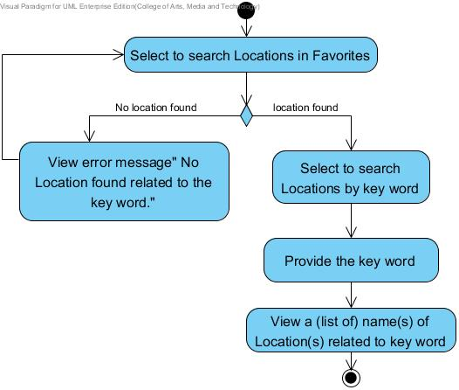

Use Case ID: | UC-15
Use Case Name: | Get the pronunciation of Location name in Favorites
Created By: | Ruijuan Liu  Yirui Wang |  | Last Updated By: | Ruijuan Liu  Yirui Wang
Date Created: |  |  | Last Revision Date:
Actors: |  | Users  Microsoft Translator API
Description: |  | This use case shows how users get the pronunciation of Location name in their Favorites.
Trigger: |  | Users select the service to get the pronunciation of Location name in their Favorites.
Preconditions: |  | 1. The service to get the pronunciation of Location name in Favorites is available.  2. The system is on running status, and is on the interface which displays a Location from Favorites.  3. The connection between system and Microsoft Translator API is available.
Post conditions: |  | Users get the proper pronunciation of the selected Location name.
Normal Flow: |  | 1. Users select the service to get the pronunciation of Location name in their Favorites.  2. System shall provide the service for users to request for the proper pronunciation of the Location name in their Favorites.  3. Users requests for the pronunciation of the selected Location name.  4. System shall send the name of the selected Location to Microsoft Translator API.  5. Microsoft Translator API shall retrieve the pronunciation data of the name.  6. Microsoft Translator API shall send the pronunciation data to system.  7. System shall receive the pronunciation of the selected Location name in Chinese.  8. System shall provide the service for users to get the proper Chinese pronunciation of the selected Location name.  9. Users get the proper pronunciation of the selected Location name.
Alternative Flows: |  | N/A
Exceptions: |  | In the step 3 of Normal Flow, there is no internet access.  1. System shall provide the user interface to display the error message. “No internet access.”  2. Use case ends.  In the step 5 of Normal Flow, there is no proper pronunciation found.  1. System shall provide the user interface to display the error message. “Cannot find the pronunciation of this word.”  2. Use case ends.
Includes: |  | N/A
Frequency of Use: |  | About 50 times per day
Special Requirements: |  | N/A
Assumptions: |  | 1. Users understand English language.  2. Users know how to operate smart phones.  3. The smart phone owns built-in speaker.
Notes and Issues: |  | 1. The speed of requesting and receiving the pronunciation of the selected Location name from Microsoft Translator API.  2. The correctness of pronunciation provided by Microsoft Translator API.

Activity Diagram:

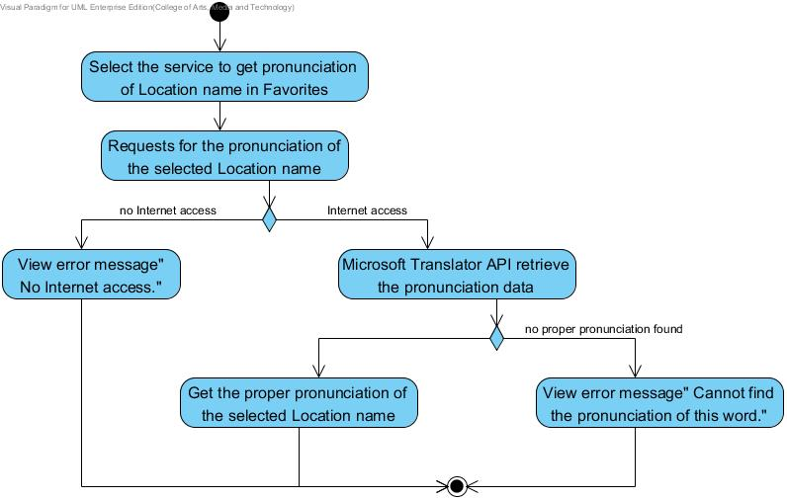
Use Case ID: | UC-16
Use Case Name: | Add scanned words into Word book
Created By: | Ruijuan Liu  Yirui Wang |  | Last Updated By: | Ruijuan Liu  Yirui Wang
Date Created: |  |  | Last Revision Date:
Actors: |  | Users
Description: |  | This use case shows how users adds the scanned words into Word book.
Trigger: |  | Users select the service to add the scanned words into Word book.
Preconditions: |  | 1. The service to add the scanned words into Word book is available.  2. The system is on running status, and is on the interface which displays the scanned word.
Post conditions: |  | System add the scanned word into database.
Normal Flow: |  | 1. Users select the service to add the scanned words into Word book.  2. System shall provide the service to add the scanned word into their own Word book.  3. Users select to add this scanned word into Word book.  4. System shall retrieve all the word data in Word book from database.  5. System shall add the scanned word into database.  6. System shall provide the user interface to display the successful message. “Word added successfully!”
Alternative Flows: |  | N/A
Exceptions: |  | In the step 4 of Normal Flow, there is an existed word which is same as the scanned word.  1. System shall provide the user interface to display the error message. “This word has existed in your Word book already.”  2. Use case ends.
Includes: |  | N/A
Frequency of Use: |  | About 50 times per day
Special Requirements: |  | The word that is added into Word book is same as the scanned one.
Assumptions: |  | 1. Users understand English language.  2. Users know how to operate smart phones.
Notes and Issues: |  | 1. The speed of adding the scanned word into Word book.  2. The correctness of adding the scanned word into Word book.

Use Case ID: | UC-17
Use Case Name: | Delete a word from Word book
Created By: | Ruijuan Liu  Yirui Wang |  | Last Updated By: | Ruijuan Liu  Yirui Wang
Date Created: |  |  | Last Revision Date:
Actors: |  | Users
Description: |  | This use case shows how users deletes a word from Word book.
Trigger: |  | Users select the service to delete a word from Word book.
Preconditions: |  | 1. The service to delete a word from Word book is available.  2. The system is on running status, and is on the interface which displays words from Word book.
Post conditions: |  | System shall delete the data of the selected word from database.
Normal Flow: |  | 1. Users select the service to delete a word from Word book.  2. System shall provide the service for users to delete a word from their own Word book.  3. Users select the service to delete a word from their own Word book.  4. System shall retrieve all the word data in Word book from database.  5. System shall provide the user interface for users to select the word that they want to delete.  6. Users select the word they want to delete.  7. System shall retrieve the data of the word selected by users from database.  8. System shall prompt users to confirm the deletion of the selected word.  9. Users confirms the deletion.  10. System shall delete the data of the selected word from database.  11. System shall provide the user interface to display the successful message. “Word deleted successfully!”
Alternative Flows: |  | In the step 8 of Normal Flow, users can select to cancel the deletion.  1. System shall provide the service for users to cancel the service of deleting the selected word.  2. Users select to cancel the deletion.  3. System shall cancel the service of deleting the selected word.  4. Use case resumes on the Step 4 of Normal Flow.
Exceptions: |  | In the step 4 of Normal Flow, there is no word found from Word book in database.  1. System shall provide the user interface to show prompt message. “No word in your Word book. You can add whatever you like.”  2. Use case ends.  In the step 9 of Normal Flow, system is not able to delete the selected word.  1. System shall provide the user interface to display the error message. “Deletion failed, please try again.”  2. Use case resumes on the Step 4 of Normal Flow.
Includes: |  | N/A
Frequency of Use: |  | About 50 times per day
Special Requirements: |  | The word that is deleted from Word book is same as the selected one.  System shall delete all the data of the selected word from database.
Assumptions: |  | 1. Users understand English language.  2. Users know how to operate smart phones.
Notes and Issues: |  | 1. The speed of deleting the selected word from Word book.  2. What kind of data of the selected word would be deleted?

Use Case ID: | UC-18
Use Case Name: | View Chinese words and related information in Word book
Created By: | Ruijuan Liu  Yirui Wang |  | Last Updated By: | Ruijuan Liu  Yirui Wang
Date Created: |  |  | Last Revision Date:
Actors: |  | Users
Description: |  | This use case shows how users view a Chinese word with its related information in Word book.
Trigger: |  | Users select the service to view a Chinese word with its related information in Word book.
Preconditions: |  | 1. The service to view a Chinese word with its related information in Word book is available.  2. The system is on running status, and is on the interface which displays words from Word book.
Post conditions: |  | System shall provide the user interface to display the selected Chinese word and related information in their own Word book.
Normal Flow: |  | 1. Users select the service to view a Chinese word with its related information in Word book.  2. System shall provide the service for users to view the Chinese words and related information in their own Word book.  3. Users select the service to view the Chinese words in their Word book,  4. System shall retrieve all the word data in Word book from database.  5. System shall provide the user interface for users to select the word that they want to view.  6. Users select the word that he/she wants to view.  7. System shall retrieve the data of the selected word in their Word book from database.  8. System shall provide the user interface to display the selected Chinese word and related information in their own Word book.  9. Users can view the selected Chinese word with its related information.
Alternative Flows: |  | N/A
Exceptions: |  | In the step 4 of Normal Flow, there is no word found from Word book in database.  1. System shall provide the user interface to show prompt message. “No word in your Word book. You can add whatever you like.”  2. Use case ends.
Includes: |  | N/A
Frequency of Use: |  | About 50 times per day
Special Requirements: |  | The word that is viewed with its related information in Word book is same as the selected one.
Assumptions: |  | 1. Users understand English language.  2. Users know how to operate smart phones.
Notes and Issues: |  | 1. The speed of retrieving the selected word in Word book from database.  2. The correctness of the selected word in Word book.  3. The completeness of the information related to the selected word.

Use Case ID: | UC-19
Use Case Name: | Sort words in Word book by date
Created By: | Ruijuan Liu  Yirui Wang |  | Last Updated By: | Ruijuan Liu  Yirui Wang
Date Created: |  |  | Last Revision Date:
Actors: |  | Users
Description: |  | This use case shows how users sort words in Word book by date when they are added.
Trigger: |  | Users select the service to sort words in Word book by date when they are added.
Preconditions: |  | 1. The service to sort words in Word book by date when they are added is available.  2. The system is on running status, and is on the interface which displays words from Word book.
Post conditions: |  | System shall provide the user interface to display a list of the  Sorted words by date. Dates are sorted from the latest to the  earliest.
Normal Flow: |  | 1. Users select the service to sort words in Word book by date when they are added.  2. System shall provide the service for users to sort the words in their Word book by date they are added.  3. Users select to sort the words in Word book by date when they are added.  4. System shall retrieve all the word data in their own Word book from database.  5. System shall sort all the words data from database by date they are added.  6. System shall provide the user interface to display a list of the sorted words by date. Dates are sorted from the latest to the earliest.  7. Users can view a list of the sorted words by date.
Alternative Flows: |  | N/A
Exceptions: |  | In the step 4 of Normal Flow, there is no word found in Word book from database.  1. System shall provide the user interface to show prompt message. “No word in your Word book. You can add whatever you like.”  2. Use case ends.
Includes: |  | N/A
Frequency of Use: |  | About 20 times per day
Special Requirements: |  | N/A
Assumptions: |  | 1. Users understand English language.  2. Users know how to operate smart phones.
Notes and Issues: |  | 1. The speed of retrieving all words in Word book from database.  2. The speed of sorting all the words by date that they are added.  3. The correctness of sorting all the words.

Use Case ID: | UC-20
Use Case Name: | Sort words in Word book alphabetically
Created By: | Ruijuan Liu  Yirui Wang |  | Last Updated By: | Ruijuan Liu  Yirui Wang
Date Created: |  |  | Last Revision Date:
Actors: |  | Users
Description: |  | This use case shows how users sort words in Word book alphabetically.
Trigger: |  | Users select the service to sort words in Word book alphabetically.
Preconditions: |  | 1. The service to sort words in Word book alphabetically is available.  2. The system is on running status, and is on the interface which displays words from Word book.
Post conditions: |  | System shall provide the user interface to display a list of the sorted words.
Normal Flow: |  | 1. Users select the service to sort words in Word book alphabetically.  2. System shall provide the service for users to sort the words in their Word book alphabetically.  3. Users select to sort the words in Word book alphabetically.  4. System shall retrieve all the word data in their own Word book from database.  5. System shall sort all the word data from database alphabetically.  6. System shall provide the user interface to display a list of the sorted words.  7. Users can view a list of the sorted words in Word Book alphabetically.
Alternative Flows: |  | N/A
Exceptions: |  | In the step 4 of Normal Flow, there is no word found in Word book from database.  1. System shall provide the user interface to show prompt message. “No word in your Word book. You can add whatever you like.”  2. Use case ends.
Includes: |  | N/A
Frequency of Use: |  | About 20 times per day
Special Requirements: |  | N/A
Assumptions: |  | 1. Users understand English language.  2. Users know how to operate smart phones.
Notes and Issues: |  | 1. The speed of retrieving all words in Word book from database.  2. The speed of sorting all the words alphabetically.  3. The correctness of sorting all the words.

Use Case ID: | UC-21
Use Case Name: | Search Chinese words in Word book
Created By: | Ruijuan Liu  Yirui Wang |  | Last Updated By: | Ruijuan Liu  Yirui Wang
Date Created: |  |  | Last Revision Date:
Actors: |  | Users
Description: |  | This use case shows how users search Chinese words in Word book by their meaning in English.
Trigger: |  | Users select the service to search Chinese words in Word book by their meaning in English.
Preconditions: |  | 1. The service to search Chinese words in Word book is available.  2. The system is on running status, and is on the interface receives the English meaning provided by users for searching Chinese word.
Post conditions: |  | System shall provide the user interface to display a (list of) related word(s).
Normal Flow: |  | 1. Users select the service to search Chinese words in Word book by their meaning in English.  2. System shall provide the service for users to search Chinese words in the Word book by their meaning in English.  3. Users select the service to search Chinese words in Word book.  4. System shall provide the user interface to receive the English meaning inputted by users.  5. Users provide the English meaning for searching Chinese word(s).  6. System retrieve the data of the word(s) from database by the English meaning.  7. System shall provide the user interface to display a (list of) related word(s).  8. Uses can view a list of words related to the searched English meaning.
Alternative Flows: |  | N/A
Exceptions: |  | In the step 6 of Normal Flow, there is no word found which is related to the English meaning provided by users in Word book from database  1. System shall provide the user interface to display the error message. “No word found related to the meaning.”  2. Use case ends.
Includes: |  | N/A
Frequency of Use: |  | About 30 times per day
Special Requirements: |  | Any words related to the English meaning that users provides must be displayed.
Assumptions: |  | 1. Users understand English language.  2. Users know how to operate smart phones.
Notes and Issues: |  | 1. The speed of retrieving all words in Word book from database by the meaning.  2. The correctness of retrieving the words in Word book from database by the meaning.  3. Any words related to the English meaning that users provide must be retrieved.

Use Case ID: | UC-22
Use Case Name: | Get the pronunciation of a Chinese word in Word book
Created By: | Ruijuan Liu  Yirui Wang |  | Last Updated By: | Ruijuan Liu  Yirui Wang
Date Created: |  |  | Last Revision Date:
Actors: |  | Users  Microsoft Translator API
Description: |  | This use case shows how users get the pronunciation of a Chinese word in Word book.
Trigger: |  | Users select the service to get the pronunciation of a Chinese word in Word book.
Preconditions: |  | 1. The service to get the pronunciation of a Chinese word in Word book is available.  2. The system is on running status, and is on the interface which displays a Chinese word from Word book.
Post conditions: |  | Users get the proper pronunciation of the selected Chinese word.
Normal Flow: |  | 1. Users select the service to get the pronunciation of a Chinese word in Word book.  2. System shall provide the service for users to request for the proper pronunciation of a Chinese word in their Word book.  2. Users requests for the pronunciation of the selected Chinese word.  3. System shall send the selected Chinese word to Microsoft Translator API.  4. Microsoft Translator API shall retrieve the pronunciation data of the word.  5. Microsoft Translator API shall send the pronunciation data to system.  6. System shall receive the pronunciation of the selected word in Chinese.  7. System shall provide the service for users to get the proper Chinese pronunciation of the selected word.  8. Users get the proper pronunciation of the selected Chinese word.
Alternative Flows: |  | N/A
Exceptions: |  | In the step 3 of Normal Flow, there is no internet access.  1. System shall provide the user interface to display the error message. “No internet access.”  2. Use case ends.  In the step 5 of Normal Flow, there is no proper pronunciation found.  1. System shall provide the user interface to display the error message. “Cannot find the pronunciation of this word.”  2. Use case ends.
Includes: |  | N/A
Frequency of Use: |  | About 50 times per day
Special Requirements: |  | N/A
Assumptions: |  | 1. Users understand English language.  2. Users know how to operate smart phones.  3. Smart phone owns built-in speaker.
Notes and Issues: |  | 1. The speed of requesting and receiving the pronunciation of the selected Chinese word from Microsoft Translator API.  2. The correctness of pronunciation provided by Microsoft Translator API.

